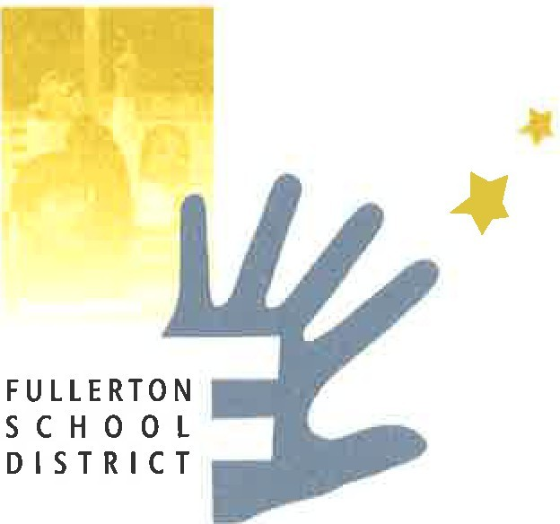FULLERTON SCHOOL DISTRICT BOARD OF TRUSTEES ANNUAL GOALS

The following goals, approved June 2023, are meant to guide the work of the Fullerton School District. They help achieve our mission to work collaboratively with the community to provide an innovative, high-quality, educational program for all students in a safe learning environment. The goals recognize the importance of integrating a diversity, equity and inclusion approach into everything we do.

# Goal 1: High Expectations for ALL Students

Objectives to reach Goal 1:

1.1 Narrow the achievement gap, measured by distance from standard for all students 1.2 Provide a foundation in literacy and mathemathics, to prepare students for success in high school, higher education, career and life.

1.3 Utilize a personalized, student-centered approach, incorporating student strengths, participation, and purpose

1.4 Promote patriotism, democracy, civic engagement, and culturally responsive instruction.

# Goal 2: Long-Term District Financial Stability

Objectives to reach Goal 2:

* 1. Exercise responsible fiscal stewardship
  2. Allocate funding to support prioritized programs, enhanced facilities, and attract and retain highly qualified staff

# Goal 3: Recruit, Hire, Support, and Retain Exceptional Staff

Objectives to reach Goal 3:

* 1. Recruit and retain exceptional and diverse staff who are culturally responsive, student-centered, and focused on high-expectations
  2. Support, encourage, and empower staff input and voice
  3. Evaluate all staff regularly to improve performance and provide targeted coaching, professional growth and development opportunities

# Goal 4: Welcome and Engage Families and Community

Objectives to reach Goal 4:

* 1. Engage families and create opportunities for input, leadership, and meaningful engagement of families in their children’s education
  2. Involve families and community in programs, committees, school cultures, and celebrations that create meaningful and culturally responsive learning and engagement opportunities
  3. Respect, empower, and celebrate our diverse families and communities

# Goal 5: Promote Safety, Mental/Physical Health, and Well-being

Objectives to reach Goal 5:

* 1. Provide child-centered programs that focus on restorative practices, nutrition, mental and social- emotional health, personal responsibility, belonging, and a positive school climate
  2. Create an environment that promotes the safety, mental/physical health, and well-being for all students and staff
  3. Strengthen and work with our community partners and community schools
  4. Promote digital citizenship, information/media literacy, and online safety both in and out of school to ensure students use technology in safe and productive ways

*Adopted by the Board of Trustees: December 11, 2012*

*Revised: October 14, 2014, November 15, 2016, January 16, 2018, November 12, 2019, November 16, 2021, June 13, 2023*